DevOps Lab Report
2025

Lab Experiment – 5 & 6

Name: Saksham Maggu
SapID: 500107116
Roll No: R2142220625
Program: B.Tech. CSE [Full Stack-AI]
Semester: 6
Batch: Batch2 (Non-Hons)


School of Computer Science
UPES, Dehradun

Exp – (i) Practice Sheet - Advanced Merging Concepts

- Fast Forward Merge
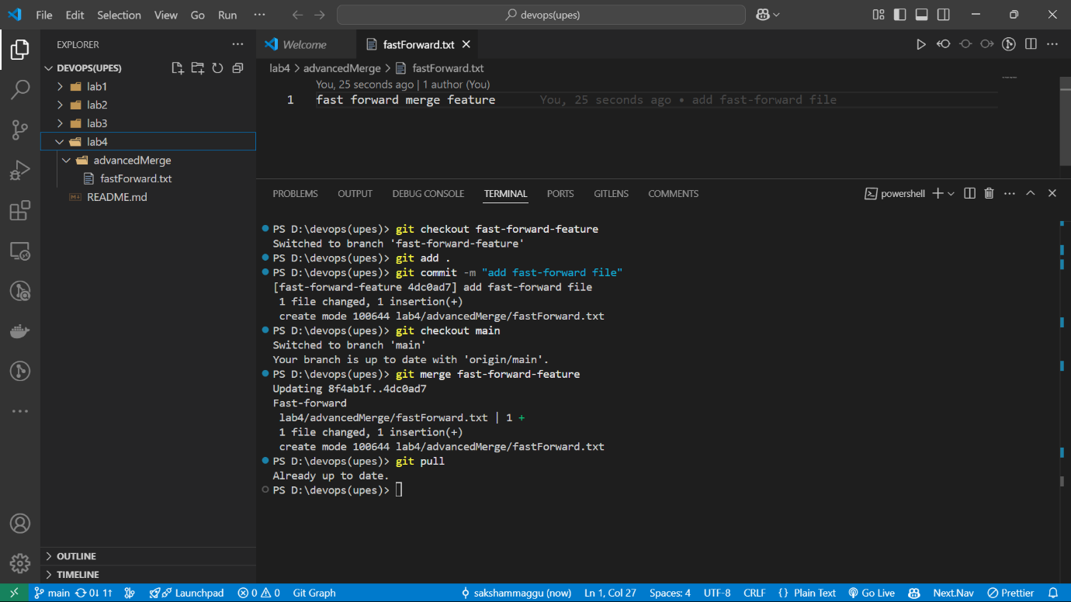

- Non-Fast Forward Merge
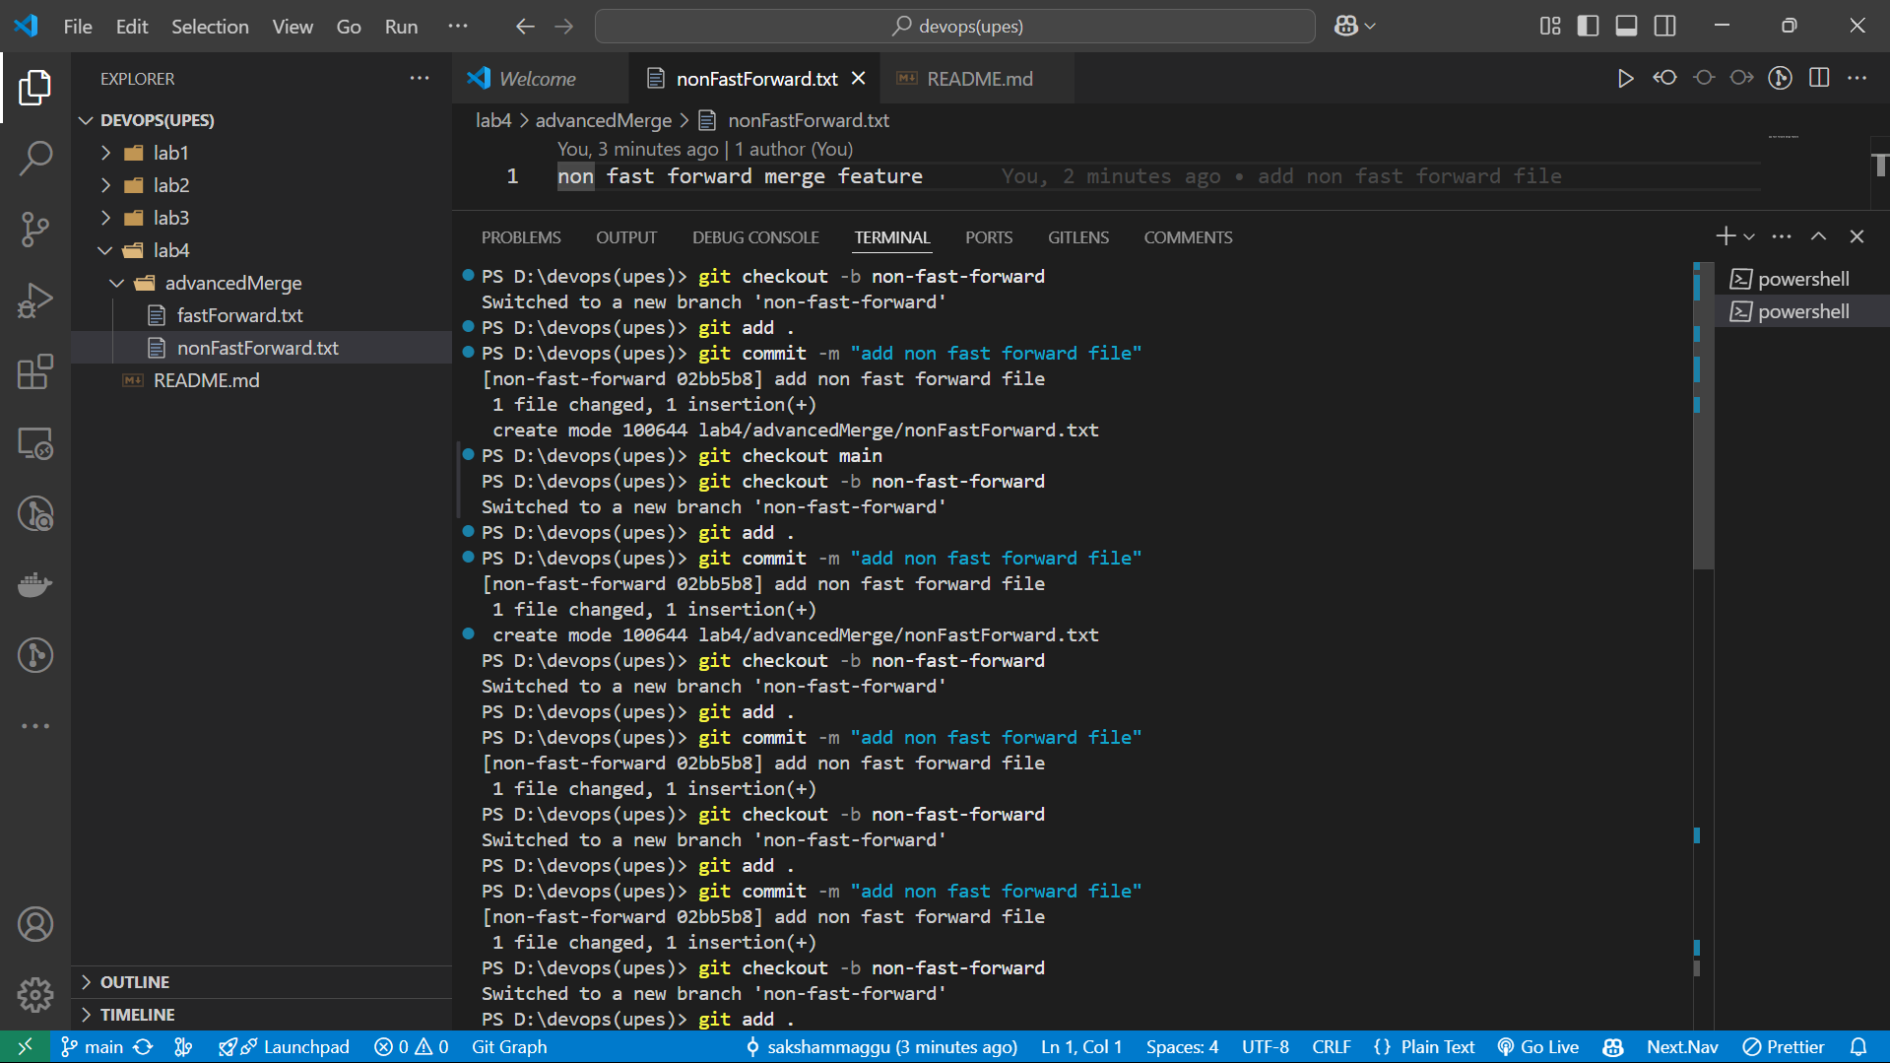

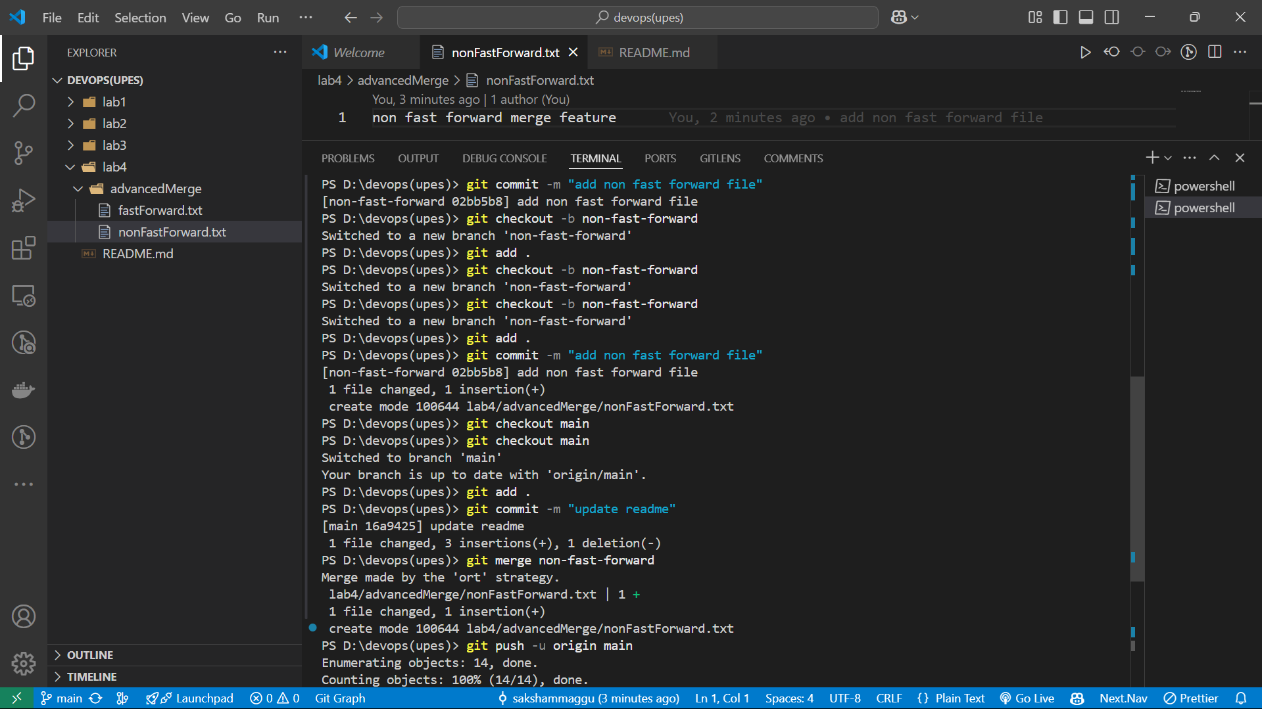

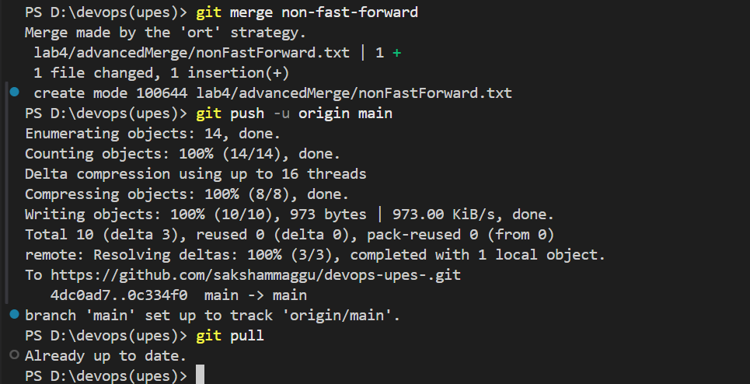

Exp – (ii) Practice Sheet – Rebasing and Commit squashing

